“The Cask of Amontillado”
Edgar Allan Poe
VISUAL LITERACY
Illustration Famed British illustrator Arthur Rackham created this image in 1935 to illustrate “The Cask of Amontillado.” Study the illustration, looking carefully at the subject matter and details.
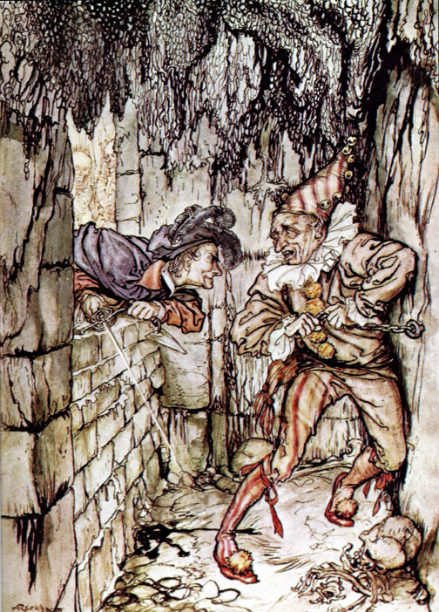
Answer the following questions in paragraph form. Use evidence from the story to support your answers.
1. How accurately does Rackham re-create the setting of “The Cask of Amontillado”? Consider the size of the niche, the
number of levels of brick, the chains, and the niter.
2. How accurately does Rackham re-create the characters? Consider their clothing, the expressions on their faces, and
their postures.
3. How well does Rackham capture the mood of this moment in the story?

